CONCEPT FOR A 1994 LAND-GRANT WATER INITIATIVE

By
First Americans Land-grant Consortium (FALCON)

The Challenge Area: Water influences every aspect of our lives: health, environment, economies, and socio-political structures. For tribal communities, stresses related to water supply, quality and management are amplified because tribes often lack the capacity to adequately respond to water-related challenges. In the context of climate change and shrinking Federal support of tribes, these challenges are sure to increase. Tribal land-grant (1994) colleges can help respond to water challenges through the development of human capacity (education/training), research on water-related problems and solutions, and community outreach and development. A national initiative that brings the 1994s together on collaborative efforts around water challenges can increase their collective impact, leverage resources, and build intra- and inter-institutional capacity.

Background: There are impressive implementations of water-related research, teaching and outreach occurring at several 1994s, but there is no collective, coordinated effort to implement water-related programming across the 1994 community. In 2015, FALCON began discussions on a 1994 water initiative, which included discussions at its annual conference, several surveys of the 1994s, and a series of conference calls into the spring of 2016. Capacities, interests and needs are varied, but student involvement in water quality testing and monitoring was a top area of interest and need. Tribes face a number of threats to water quality from point and non-point source pollutants that negatively impact drinking water, agricultural water, and habitat for traditional sources of food, medicine and fiber. 1994s can provide tribes with the baseline data and continuous monitoring to determine trends and vulnerabilities, and can assist in adaptation planning.

There are currently several water-related projects that can serve as a springboard for a future initiative. First, FALCON is a partner on a USDA-funded research project in the Great Basin called “Arid Waters on Native Lands” that is studying how tribal communities manage and adapt to changing water conditions. Second, Salish Kootenai College (Pablo, MT) is working to enhance its four-year hydrology degree program—other tribal colleges are likewise pursuing water initiatives. Third, the Northcentral Region Water Network is proposing an 1862/1994 water summit to explore collaboration with the northcentral region.

Proposed Implementation: A 1994 water initiative could be implemented in several steps or phases, such as:

Phase I: Planning (about 2-4 months): A working group of representatives from interested 1994s, FALCON, AIHEC, and USDA begin a planning process that collects all relevant data, determines top needs and priorities, identifies funding sources, develops project goals and plan, and secures partnerships and support. This is essentially what the conference calls have started, but calls would become more targeted moving forward. Some seed money and human capacity is needed to do this.

Phase II: Resource Development/Funding (about 3 months): The working group recruits a set of collaborative institutions that then seeks funding to implement a 1994-wide water program, to be determined in the planning phase. We can see at least three major options: A) This might be an online distance education water quality monitoring AAS degree program; or B) it could be a resource toolkit for extension-led community work; or C) maybe a collaborative research program.

Option A: For argument’s sake, assuming an online distance education water quality monitoring AAS degree program, the project plan could include a market analysis of workforce needs, the development of curricula, accreditation standards, articulation and cooperative agreements, and the sharing of faculty, lectures and lessons and student counts. Instead of building a new degree program, enhancement of current degree programs could be addressed by developing a menu of curricula that could be selectively implemented at each 1994.

Option B: A resource toolkit for extension work might follow a similar path: needs assessments of tribal community priorities, then the development of curricula (fact sheets, lesson plans, testing/monitoring protocols, etc.), cooperative agreements and then the sharing of resources and expertise among the 1994s. Extension programming represents an easier path because it doesn’t require formal accrediting and articulation, and doesn’t have to pass the student enrollment test—that there are enough student enrollments to justify the work. It could still have a strong student connection through service learning experiences and/or student internships. Once extension curricula is developed, it could be adapted into for-credit coursework relatively easily if that’s desired.

Option C: The nature of research funding means that a research project would need to be targeted much more to a specific research question or problem, and so would probably involve a smaller set of 1994s, with less applicability to the larger 1994 community. Research funding would also be more constrained by time, as long-term on-going funding is harder to justify.

Phase III: Implementation: Assuming secured funding, implement the proposed plan. Evaluate and disseminate outcomes and impacts. Work toward sustainability of the initiative.

FALCON’s Role: FALCON can help secure the support necessary to help implement a national 1994 water initiative. 1994s are resource-constrained institutions operating at over-capacity, and often lack the resources needed to implement new initiatives. This is particularly the case with human resources because 1994s are generally located in remote and isolated areas with a limited qualified labor pool. FALCON can help provide expertise to help implement local projects and management plans. With regard to water, FALCON can help in at least four specific areas:

- assessment/planning: including strategic planning, climate change vulnerability/adaptation planning, water management planning, etc.;
- project implementation: including water/natural resource management and interventions, curriculum development, community outreach/education, etc.;
- research: including collecting baseline data, installing monitoring stations, water modeling, etc.; and
- resource development: including grant proposal writing, developing resource-sharing partnerships, and fundraising.

Recommendation: Proceed with Option B, keeping the door open to Option A as appropriate. Option B, an extension-focused approach, represents the easiest path toward planning and implementation. It does not preclude pursuing Options A or C down the road. In fact, it helps build the necessary justification for those efforts. Extension materials should be designed so that they can easily be used to enhance academic programs.

There are several really cool implementations of this approach below. You can see that much materials have already been developed, and this may be largely a matter of repackaging and coordination…..

Highlighted Projects

Water Quality
In 1999, Gorno-Altaisk State University (GASU) (link is external), Haskell Indian Nations University (HINU), (link is external) Kansas State University (KSU), (link is external) and the University of Kansas (KU) (link is external)joined together to create a partnership to address water quality issues common to both the Russian Federation and the U.S. With initial funding from the U.S. Agency for International Development/ Association Liaison Office, the partners engaged in exchange activities to develop a model program for community-based drinking water quality monitoring in rural villages in the Altai Republic of Russia, which would be culturally relevant to indigenous populations living in remote areas.
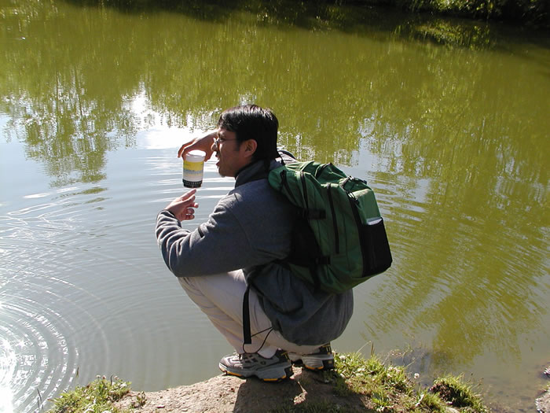
Haskell student collecting water sample for on-site analysis
During the three year project, the partnership trained Russian and U.S. partner institution participants in scientifically rigorous water quality assessment methodology, and in capturing and interpreting traditional ecological knowledge. It also provided training modules suitable for use by elementary and secondary schoolteachers and community groups who will form a water quality monitoring network in the Altai Republic.

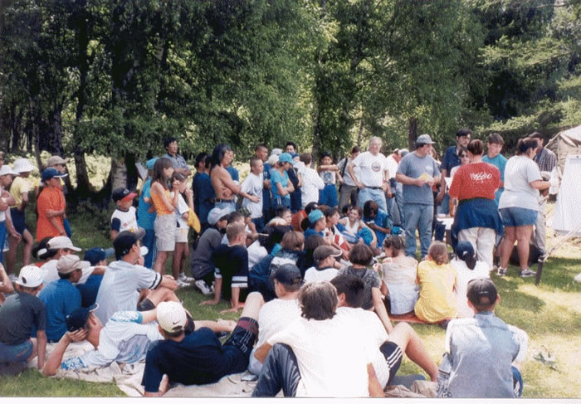
Children at summer camp learning about water quality
This project initiated a technical environmental extension capacity at GASU, and provided the first international student and faculty exchange opportunity for HINU. Heidi Mehl (KU graduate student) is completing her Masters thesis on this work in the Indigenous Nations Studies Program, and has used these techniques in her work with the Potawatomi Boys and Girls Club while she worked for U.S. Geological Survey.
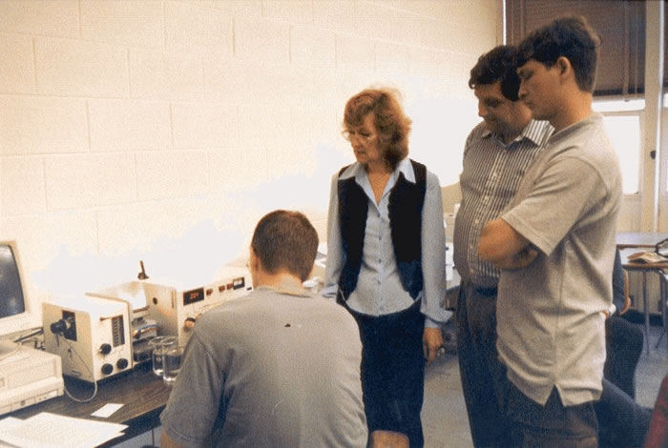
GASU and Kansas students and faculty conducting water
sample analysis in Kansas
Like in Kansas, one of the major water quality problems in the Altai is coliform bacteria from livestock.

Tribal Water
Tribal Water Management Videos
MSUEWQ worked with Salish-Kootenai College (SKC) and a student from the MSU Science and Natural History Film Making Program to produce two films about water issues in Indian Country. The first video focuses on water quality and the Clean Water Act and the second overviews Indian Water Rights.

Apsáalooke Tribe Water Quality Monitoring Training and QAPP Development
MSUEWQ has been working with Little Big Horn College (LBHC) since 2006 to provide water quality monitoring training for summer interns. In the summer of 2008, MSUEWQ worked with faculty and students at LBHC to draft a quality assurance project plan (QAPP) document to outline the monitoring that the interns conduct. The QAPP continues to be refined as the methods evolve and the capacity of the LBHC program develops.
Water quality monitoring efforts on the Apsáalooke (Crow) Reservation are conducted in collaboration with a number of partners including LBHC faculty and students, MSUEWQ, the Crow Tribe Environmental Program, the USGS, the MSU Microbiology Department, and the Crow Environmental Health Steering Committee.
Water Quality Education Capacity Building for Tribal Colleges and Hispanic Serving Institutions (HSI)
Water quality education has been identified as a need at tribal colleges and in Indian Country in general. However, tribal college faculty often lack water quality expertise and the extensive teaching loads which are typical at tribal colleges make developing new material daunting or impossible. To address this need, MSUEWQ worked with Salish-Kootenai College (SKC) and the Northern Plains and Mountains Regional Water Program to create a water quality teaching package for tribal college faculty. The package contains PowerPoint presentations with instructor notes, assignments, suggested readings, example tests. The teaching package is available at no charge to tribal college faculty and provides extensive materials for an instructor to build a water quality course or incorporate water quality lessons into existing science courses.

Water Quality Teaching Package
Introduction:
MSUEWQ worked with Salish Kootenai College and the Northern Plains and Mountains Regional Water Program to develop a water quality teaching package. The package provides materials to support a college level water quality course to enhance water science education capacity at tribal colleges. Included are a list of lessons, lesson summaries, 25 PowerPoint lesson presentations with instructor notes, 5 assignments, 3 test examples, a term paper assignment, a pre-test, a list of books and resources that may be used, and two videos with associated case study outlines. Lab activities will soon be added to the teaching package with detailed instructions on how to prep for the activity, how to perform the activity, materials needed, and homework assignments.

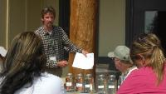
Lesson Topic List
- Example lecture with teaching notes
Getting the Package
If you are interested in obtaining a copy of the full teaching package, please contact us. We can electronically send files that include an outline of the teaching package and all of the lesson powerpoints, Word and Excel files for assignments, and videos.
Contact the Extension Water Quality program at: ExtensionWater@montana.edu or call 406-994-7381

